# Set Point Tracking Controllers:

## PD controller with Gravity Compensation:

x0_s=[4, 2, 2, 2]; %initial conditions for the state vector

xf_s=[0 0 0 0]; %final state for set point tracking control

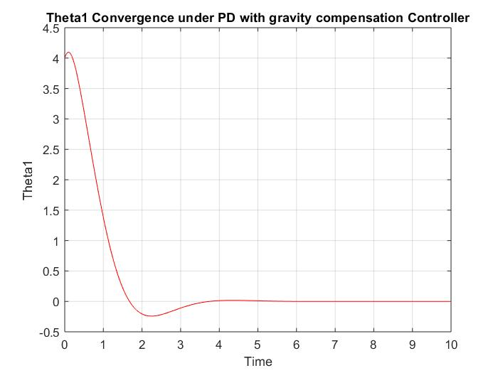

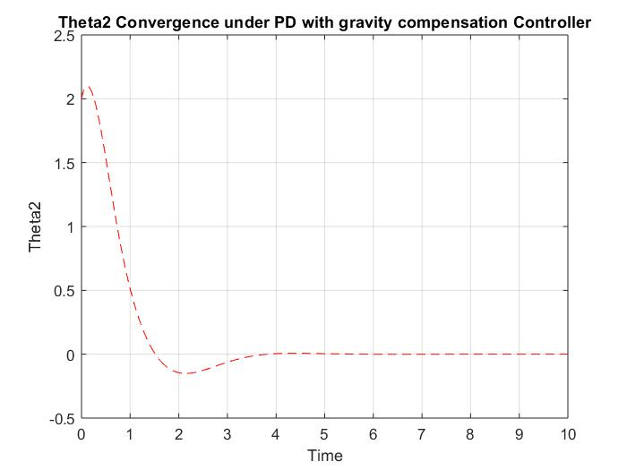

## Iterative Learning Controller:

x0_i=[-0.5, 0.2, 0.1, 0.1]; %initial conditions for the state vector

xf_s=[0 0 0 0]; %final state for set point tracking control

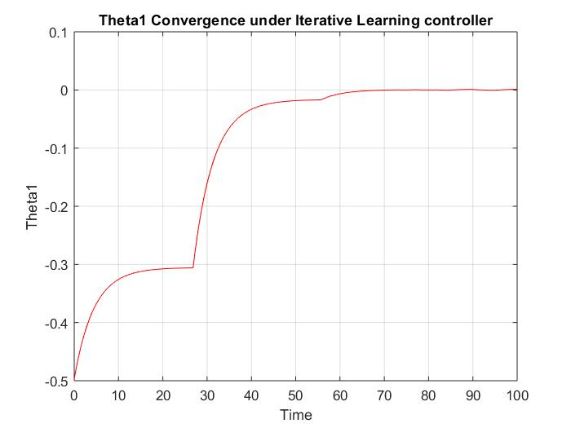

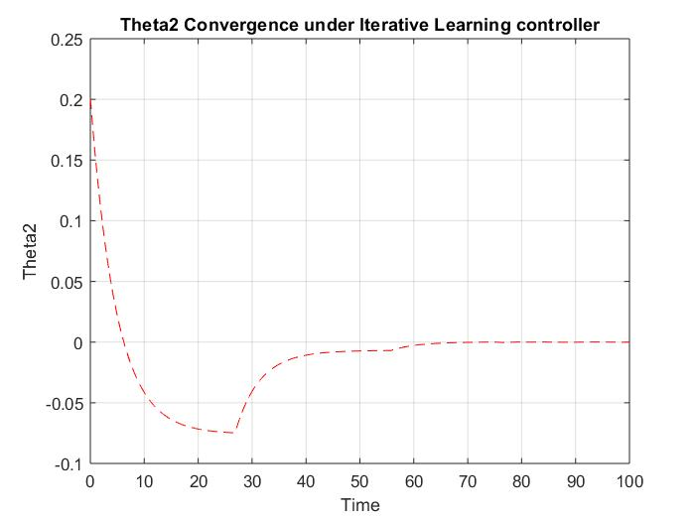

# Tracking Controllers

## Inverse Dynamics Controller, Lyapunov Based Controller and Passivity Based Controllers.

x0=[30 30 2 1]; %Setting initial conditions for the state vector

x0_traj=[30 30 2 1] %Initial condition for the trajectory (without initial error)

x0_traj_e=[5 1 0.3 0.1] %Initial condition for the trajectory (initial error)

xf = [50,40, 5, 5]; %Final state desired

Tracking Control without initial errors from the trajectory: The system response is exactly following the trajectory.

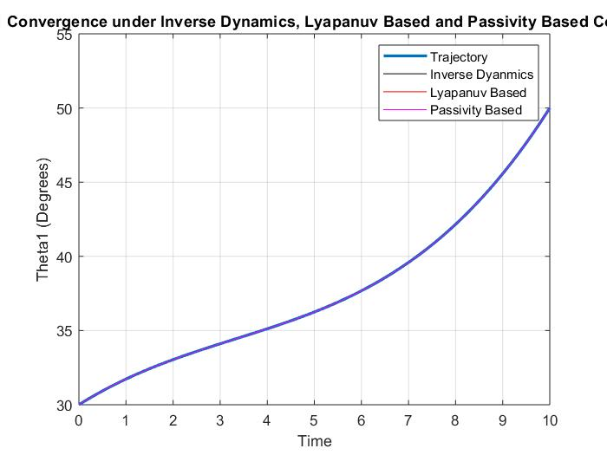

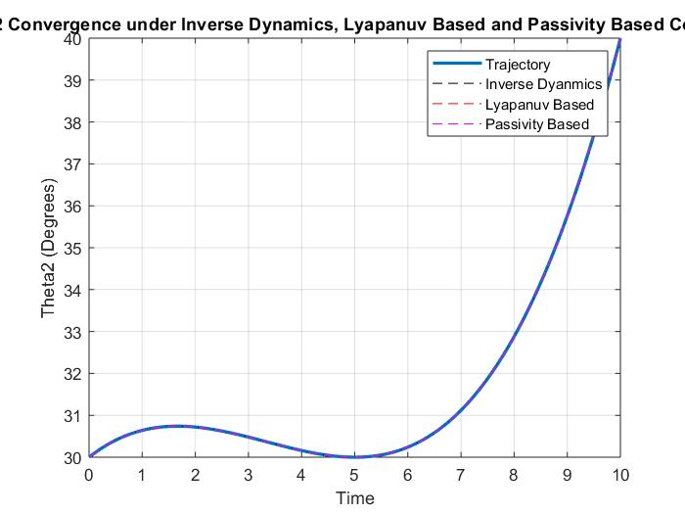

Tracking Control with initial errors from the trajectory: The system is converging under the 3 controllers as shown below.

